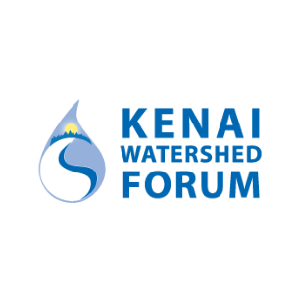

Kenai River

Water Quality Action Framework – Part II
Analysis and stakeholder engagement to guide
management of Alaska’s Kenai River Watershed

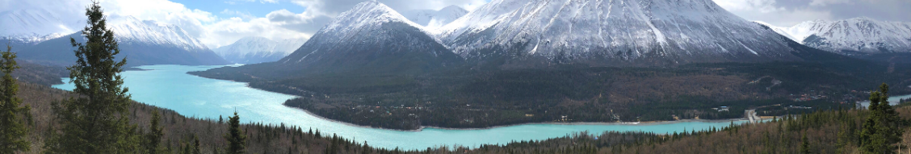

Bureau of Reclamation
WaterSMART Cooperative Watershed Management Program Phase I
Funding Opportunity Announcement No. R23AS00362

Submitted by:
Kenai Watershed Forum
44129 Sterling Hwy
Soldotna, AK, 99669
Submitted to:
Bureau of Reclamation
Financial Assistance Operations Section
ATTN:NOFO Team
P.O. Box 25007, MS 84-27133
Denver, CO 80225

Project Officer:
Trent Dodson
executivedirector@kenaiwatershed.org, (907) 260-5449

Table of Contents
Technical Proposal
Executive Summary 1
Acronyms & Abbreviations 2
Project Location 2
Technical Project Description 5
Applicant Category 5
Eligibility of Applicant 8
Goals 9
Evaluation Criteria 14
A. Watershed Group Diversity and Geographic Scope 14
B. Addressing Critical Watershed Needs 16
D. Department of the Interior and Bureau of Reclamation Priorities 20
Project Budget 21
Budget Proposal 21
Budget Narrative 21
Appendix 23
References 24
Environmental and Cultural Resources Compliance 26
Required Permits and Approvals 26
Overlap or Duplication of Effort Statement 26
Conflict of Interest Disclosure Statement 27
Uniform Audit Reporting Statement 27
SF-LLL: Disclosure of Lobbying Activities 27

Acronyms & Abbreviations
ADF&G - Alaska Department of Fish & Game
ADEC - Alaska Department of Environmental Conservation
AKDNR - Alaska Department of Natural Resources
CWA - Clean Water Act
CWMP - Cooperative Watershed Management Program
DOI - United States Department of the Interior
EPA - United States Environmental Protection Agency
HUC - Hydrologic Unit Code
KPB - Kenai Peninsula Borough
KPFHP - Kenai Peninsula Fish Habitat Partnership
KRBWQM - Kenai River Baseline Water Quality Monitoring
KRCMP - Kenai River Comprehensive Management Plan
KRSMA - Kenai River Special Management Area
KWF - Kenai Watershed Forum
QAPP - Quality Assurance Project Plan
QA/QC - Quality Assurance / Quality Control
Reclamation - United States Bureau of Reclamation
USFS - United States Forest Service
USGS - United States Geological Survey

Technical Proposal
Executive Summary
August 30th, 2024, Kenai Watershed Forum, Soldotna, Kenai Peninsula Borough, Alaska.

Kenai Watershed Forum (KWF) is a community-based 501(c)(3) nonprofit organization founded in 1997 that works through partnerships to ensure healthy watersheds on the Kenai Peninsula of southcentral Alaska, providing high-quality education, restoration, and research programs focused on water quality, fish habitat, and ecological resilience. KWF’s partnerships with other nonprofits, government agencies, philanthropic foundations, and corporate entities have strengthened local conservation efforts, creating a culture of science driven, collaborative watershed management. The proposed project will take place in the Kenai River watershed, an area that includes large swaths of federal public lands and a diversity of state, city, and private property. The Kenai River is a stronghold for wild Pacific salmon, in particular Chinook and sockeye salmon, and is vital to the region’s culture, economy, and ecosystem. Development, climate change, and intensive recreational use threaten wild freshwater fish habitat, and through this project, KWF will work with key stakeholders to develop cooperative management strategies to maintain the Kenai River’s water quality. KWF possesses a robust water quality data set from the Kenai River watershed spanning from the year 2000 to present time, gathered with support of numerous community partners. KWF proposes to build upon successes achieved in our previous WaterSMART Cooperative Watershed Management (CWMP) project, using open-source, reproducible data science to curate and publicly archive KWF’s historic water quality data, as well as developing a quality assurance pipeline to address annual data management needs. In this new proposed two year CWMP Phase I project ending in September 2027, KWF will a) ensure that all current data is accessible in an online interactive interface for both laymen and professionals, b) up-to-date technical results are communicated to local stakeholders and feedback is received in a series of meetings, and c) finalize a Kenai River Water Quality Action Framework, a document intended for a general audience of managers and property owners to guide future water quality management of the Kenai River watershed. The proposed project presents a unique opportunity to provide a highly engaged community with the tools to ensure that existing ecological infrastructure continues to serve as the keystone of the local economy, culture, and ecosystem.

- Project time period: October 1, 2025 - September 2027.
- The proposed project area includes federal lands within Chugach National Forest, Kenai National Wildlife Refuge, and Kenai Fjords National Park.

Project Location
The Kenai River is a glacially-fed system located on the Kenai Peninsula in southcentral Alaska in the Kenai Peninsula Borough (KPB). The borough includes most of the peninsula as well as a large land area to the west of Cook Inlet with a total land area of 16,075 square miles, equal to Massachusetts and New Jersey combined. According to the 2020 census, the borough has a population of 59,000 with the vast majority of those individuals living on the peninsula. Of the nearly 16 million acres that make up KPB, approximately 87% is federal or state land, with the remainder owned by the borough, city, Tribal, or private entities (KPB 2019; U.S. Census Bureau 2020).

The gem of the borough is the Kenai River watershed, which covers 1.38 million acres including nearly 75,000 acres of wetlands and includes the towns of Cooper Landing, Sterling, Soldotna, Kenai, and a number of small rural communities (Figure 1). The watershed is located largely within the United States Geological Survey (USGS) Hydrologic Unit Code (HUC) 19020302. With over 150 miles of state-listed anadromous waters, the watershed hosts six species of Pacific salmon including Chinook (Oncorhynchus tshawytscha), sockeye (O. nerka), pink (O. gorbuscha), chum (O. keta), coho (O. kisutch), and steelhead (O. mykiss). Salmon runs reach millions of fish that utilize the watershed for rearing and spawning habitat alongside 29 other species of fish including Pacific and arctic lamprey, Dolly Varden, and hooligan or eulachon.

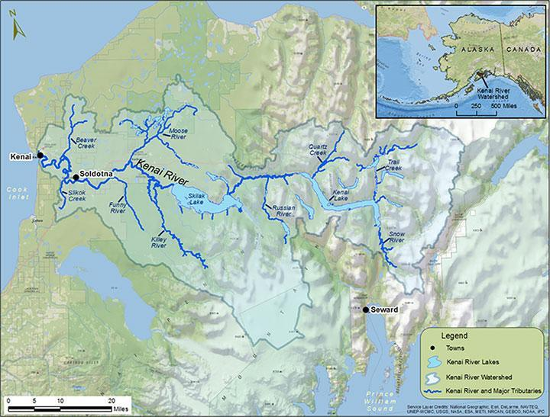
Figure 1. Map of the Kenai River watershed on Alaska’s Kenai Peninsula. The Kenai River mainstem is 82 miles long and begins in the town of Cooper Landing at the outlet of Kenai Lake.

Salmon are critical to the Alaskan economy, recreation, and culture. The Kenai river is uniquely productive, historically producing 35% of the salmon commercially harvested in the Cook Inlet basin, including 80% of the sockeye salmon, despite occupying less than 6% of the basin area (Dorava and Milner 2000). The watershed is also uniquely accessible, positioned on Alaska’s limited road system while supporting commercial, recreational, personal use, and traditional & customary (subsistence) fisheries. In part because of the bounty of salmon the watershed produces, distinct groups of Alaska Native people have resided in the watershed for thousands of years, and there are many archaeological sites of significance. Kenaitze Dena’ina people still live in the watershed and recognize a spiritual connection to the Kenai River, which is referred to as Kahtnu in the Dena’ina language.

- The “Upper River” extends from Kenai Lake, fed from the Sargent Icefield via the Snow River, through Skilak Lake, a 25,000 acre lake that is also fed by the melt from Skilak Glacier, part of the Harding Icefield. Major tributaries of the Upper River are the Snow River and the Russian River, which is known for two separate runs of sockeye salmon that draw anglers from around the world. Other tributaries include Quartz Creek and Trail Creek.
- The “Middle River” flows from the outlet of Skilak Lake to the Sterling Highway bridge in the City of Soldotna. Significant development along the river begins in the Middle River at the boundary of Kenai National Wildlife Refuge. Major tributaries of the Middle River include the Moose River, Killey River, and Funny River as well as Soldotna Creek.
- The “Lower River” extends 21 miles from Soldotna to the river’s mouth into Cook Inlet in the City of Kenai. The Lower River is tidally influenced up to river mile 12 from the Cook Inlet and includes a large estuary that is frequented by beluga whales, harbor seals, and sea lions. The estuary provides habitat for an array of birds and includes the Kenai River Gull Rookery, home to thousands of nesting seabirds each summer. This area includes the Kenai Port, which is the 37th largest port in the country by value of seafood landings (“KPEDD” 2020). Tributaries of the Lower River include No Name Creek and Beaver Creek, both of which are included in the water quality data set described in this proposal.

Aside from private lands in Cooper Landing, much of the watershed’s headwaters are on federal lands in Kenai National Wildlife Refuge, Chugach National Forest, and a small section in Kenai Fjords National Park. The State of Alaska and multiple local governments also manage lands in the watershed. These agencies coordinate management of the Kenai River Corridor in an interagency forum called the Kenai River Special Management Area (KRSMA). Much of the land in the lower watershed is privately owned and significant development along the Kenai River begins in the town of Sterling and continues to the Cook Inlet. There is also oil and gas production in the watershed with the highest concentration of land based wells in the Beaver Creek Unit north of the City of Kenai.

There are 1,800 private land parcels on the Kenai River shoreline through the Middle and Lower River. Developed area in the watershed increased by 20 times from the 1950s (Schoen et al. 2017) (Figure 2).

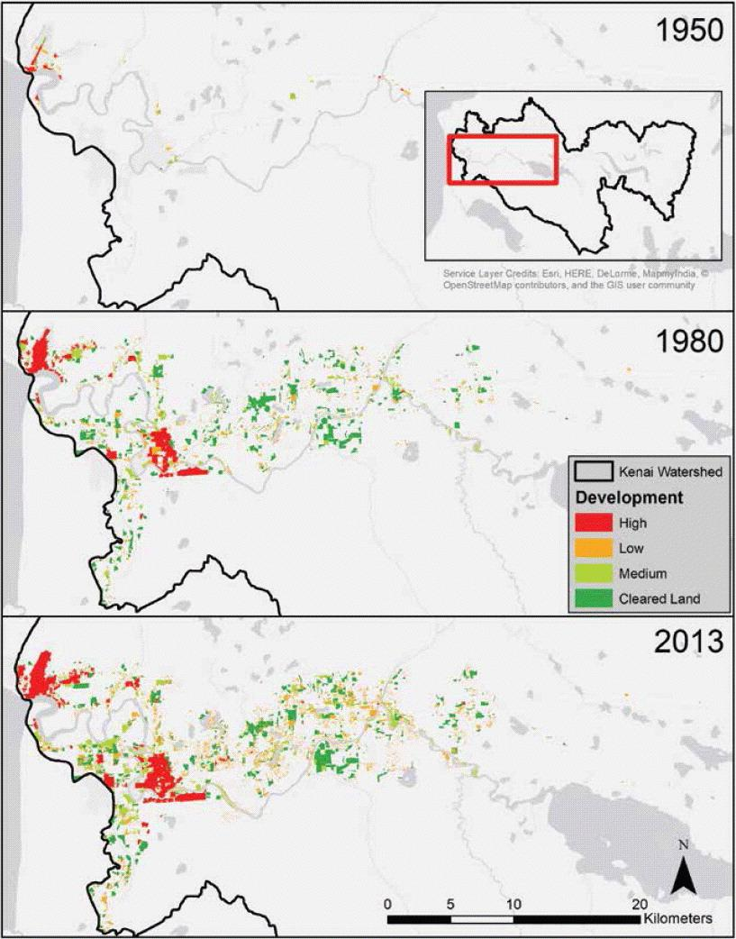
Figure 2. The expanding footprint of human development in the lower Kenai River watershed based on analysis of aerial photographs. Development is concentrated in lowlands near the river mainstem and tributaries. Figure from Schoen et al. 2017, adapted with permission of authors.

While the majority of the watershed remains undeveloped, the impacts of impervious surfaces, runoff, the clearing of forests, and other landscape changes related to development have had a significant impact in the watershed, especially in the lower river region. For example, recent analyses have indicated a potential relationship between highway traffic volume and dissolved copper concentrations in the lower Kenai River (Sires 2017a). Between 1984 and 2022 alone, impervious surface coverage in the lower Kenai River increased by nearly 20% (Kenai Watershed Forum 2024a).

While the Kenai River itself is not a drinking water source, it is hydrologically connected to groundwater that is used for drinking water. For example, groundwater drawn from adjacent to Beaver Creek, a major tributary of the Kenai River, is the sole source of municipal drinking water for the City of Kenai. Groundwater/surface water interaction in the watershed is an active topic of research, with current investigations underway by the US. Geological Survey and Kenai Watershed Forum (Leaf et al. 2023)

As a result of its large salmon runs, connection to the road system, and proximity to the state’s largest population center in Anchorage, the Kenai River hosts the most popular freshwater sport and personal use fisheries in Alaska. While it is most well-known for its Chinook (King) salmon fishery, the river supports other major sport fisheries including sockeye and coho salmon. Pink salmon, rainbow trout, and Dolly Varden are also fished recreationally from the river. Because of anthropogenic pressures facing the Kenai River, it is a priority for conservation efforts (ADEC 2020a).

Technical Project Description

Applicant Category
KWF is an Existing Watershed Group under the statutory definition cited by the United States Bureau of Reclamation (Reclamation). KWF was founded in 1997 through a grassroots effort by local stakeholders to form a collaborative, non-governmental 501(c)(3) organization to facilitate research, education, and restoration projects in the Kenai River watershed. Since its founding, KWF has focused on understanding, protecting, and restoring water quality; mapping, reconnecting, and restoring aquatic habitat; and providing environmental education to the local community and general public through volunteer programs, outreach events, summer camp, and school programs. KWF works directly with a wide array of partners and stakeholders. Through many successful collaborative efforts, KWF’s geographic scope expanded to cover the entire KPB - a region approximately the size of West Virginia - and the organization’s mission was established, “working together for healthy watersheds on the Kenai Peninsula.”

In KWF’s 27 year history, the organization has participated in and coordinated a numerous watershed management projects:

- Kenai River Baseline Water Quality Monitoring (KRBWQM): Of particular relevance to the proposed project, KWF spearheads water quality monitoring throughout the Kenai River watershed to study nonpoint source pollution. In 1997, Alaska Department of Natural Resources (AKDNR), Alaska Department of Fish & Game (ADF&G), and KPB adopted the “Kenai River Comprehensive Management Plan'' (KRCMP) (AKDNR 1997). In chapter 4.5, Area Wide Recommendations, section 10.2.2., the agencies state that, “Water quality information should be collected on a systematic, long-term basis.” The purpose of such a program should be to “assess the status and trends in the water quality of the river” and to “link the status and trends to an understanding of the natural and human factors that affect water quality.” The agencies specify that such a program “must be integrated among many agencies that have differing objectives and must be of long term duration.” Through conservation action planning following the adoption of the KRCMP, a technical working group led by The Nature Conservancy established the framework for a baseline water quality monitoring program. This effort led to the founding of KWF as the entity who would coordinate the monitoring project. The dataset now includes 24 years of data, and KWF continues to manage the KRBWQM program. Using a Quality Assurance Project Plan (QAPP) approved by the Region 10 U.S. Environmental Protection Agency (EPA) office (KWF 2023), KWF collects data on a biannual basis. KRBWQM operates under a memorandum of understanding with program partners including Kenaitze Indian Tribe, ADF&G, KPB, ADEC, United States Forest Service (USFS), City of Kenai, City of Soldotna, and Cook Inlet Aquaculture Association, among others. These partners fund the annual sampling and analysis costs, and KWF is not requesting any funds for these activities through the CWMP. In an example of KRBWQM success, KWF identified hydrocarbon pollutants in the river in excess of U.S. EPA water quality standards that resulted in the listing of the Kenai River under section 303(d) of the Clean Water Act (CWA) (EPA 2011). A local coalition was formed that successfully pursued policy to mitigate the problem, including a requirement for four-stroke boat motors on the river and a buy-back program for two-stroke boat engines that had been the source of the pollutants. The program was a success and in 2010, the river was removed from the CWA 303(d) list of impaired waters. More recently KWF identified potentially increasing levels of zinc and copper in the watershed (E. J. Guerron Orejuela 2017), known toxins to salmon and other aquatic life. Sampling for these parameters is ongoing with the goal of better understanding the nonpoint source pollution problem and establishing mitigation actions that various stakeholders can achieve, including an expanding collaboration with Kenaitze Indian Tribe environmental interns that will run 2025 - 2027. A new community grant from ConocoPhillips is providing resources to professionally film a series of videos highlighting project goals and training techniques, and will be available on KWF’s YouTube channel in Fall 2024.

- Southcentral Alaska Hydrologic Mapping: KWF has been a leader in the State of Alaska conducting hydrologic mapping for a variety of purposes. These data are used by KPB and other entities for a variety of management applications, and are available to the general public in the Borough’s public online parcel viewer. including:
  - Hydrological Maps - beginning in 2011, KWF undertook a large project to modernize hydrological maps of the KPB by updating the National Hydrography Dataset.
  - Wetlands - KWF mapped and classified 350,811 acres of Cook Inlet wetlands outside of federal lands.
  - Anadromous (salmon habitat) waters mapping - KWF annually submits and updates spatial and temporal information about streams included in the Anadromous Waters Catalog, a list of waters utilized by anadromous species maintained by ADF&G. Recent efforts from 2021 - 2024 mapped 21 miles of previously unrecognized salmon habitat adjacent to growing residential areas in the central Kenai Peninsula.
  - Flow reservations - KWF filed for flow reservations for Slikok Creek and Beaver Creek, both anadromous waterways, to ensure that the stream would have sufficient water quantity to support habitat for salmon and other species. A similar effort is currently in progress for Soldotna Creek. All are major tributaries of the Kenai River.

- Participation in Local Water Management and Policy Development: As a local community-based nonprofit, KWF has long played a role in advising decision makers on matters related to watershed management. KWF was instrumental in the creation of KPB 21.18 Anadromous Waters Habitat Protection ordinance (KPB 2013) to protect riparian habitat along anadromous river corridors, and the KWF executive director sat on the most recent KPB Anadromous Waters Habitat Working Group.

- Fish Passage Improvement: In KWF’s assessments of 270 local culverts a decade ago, only 48 provided adequate fish passage. With various partners KWF has replaced 71 of the inadequate culverts that blocked fish passage and reconnected over 2,000 miles of anadromous fish habitat. These projects have ranged in scale from small to large streams. Notable projects include the replacement of the Crooked Creek culvert that passes beneath the Sterling Highway south of Soldotna. Following the culvert replacement, KWF conducted a monitoring project in which juvenile coho salmon were tagged to monitor movement after the culvert’s replacement. Fish movement data from this project (2018-2020) immediately demonstrated the effectiveness of culvert replacement as a critical habitat restoration technique. In 2024, KWF is currently in process of replacing another failing culvert on Soldotna Creek with a modern structure that accommodates floods and fish passage. KWF is also currently leading local efforts to quantitatively prioritize borough-wide fish passage projects, in partnership with the River Focus Water Resource Consultants.

- Environmental education: A long-standing and nationally recognized environmental educational program of the KWF, Adopt-A-Stream has been successfully delivering natural resource education to a broad audience of children and adults since 2006. Through a hands-on and engaging model, Adopt-A-Stream aims to support the connection between healthy watersheds, salmonid life cycle, and ecosystem conservation which benefit both water quality and local fish and wildlife habitat. K-12 students on the Kenai Peninsula adopt a nearby stream site to monitor and protect, leading to significant environmental investigations, curiosity, and active environmental stewardship. Additional programs include KWF’s annual River Fair, an all-day environmental-education focused event for all ages, as KWF’s River Table, a mobile hands-on teaching tool for hydrology.

- Invasive species: KWF hosts an Invasive Species Program that has been a leader in invasive species management on the Kenai Peninsula for almost two decades. Through this program, KWF focuses on the most threatening and detrimental non-native species on the Kenai Peninsula through Integrated Pest Management (IPM) and Early Detection and Rapid Response (ED&RR) techniques. KWF also seeks to prevent the introduction of new, non-native species through education and outreach programs across the Kenai Peninsula. KWF has played a vital role in creating, promoting, and contributing to the goals of the Kenai Peninsula Cooperative Invasive Species Management Area (KP-CISMA) to keep the Kenai Peninsula free from the detrimental effects of invasive species since its inception as a Cooperative Weed Management Area in 2003. KWF’s Restoration Coordinator serves as the KP-CISMA Field Coordinator where we collaborate with KP-CISMA partners to implement KP-CISMA management priorities on public lands throughout the Kenai Peninsula and support landowners in making sound management decisions concerning invasive species.

- Kenai Peninsula Fish Habitat Partnership (KPFHP): Since January 2010 KWF has administered and coordinated the KPFHP, part of the network of National Fish Habitat Partnerships (18 total) including continuous participation from current Borough Mayor Peter Micciche. Since its inception, the KPFHP has received over $2.5 million for coordination and partner projects, and has leveraged that funding for an additional $3.7 million in partner matching funds. KPFHP operates under a strategic plan that identifies the focal areas of the partnership and the needs of partner organizations. Water quality and water quantity make up 25% of the partnership’s focus. This focus is further supported by the partnership’s recently-updated freshwater Conservation Action Plan, developed by partners to identify the greatest threats to fish habitat in the region (KPFHP 2022). Each year KWF administers the partnership’s efforts via an established steering committee, and since its inception has funded projects with other KPFHP partners to achieve its mission “to protect, maintain, restore, and enhance fish habitat.” The partnership has supported and in some cases helped fund KRBWQM.

- Mountains to Sea: The Kenai Peninsula has vast amounts of federally protected public lands and habitat in Chugach National Forest, Kenai National Wildlife Refuge, and Kenai Fjords National Park. However, between this habitat and Cook Inlet is a large area of land that is privately held. Mountains to Sea is a landscape scale conservation project that is working with agencies and private landowners to ensure the watersheds, in particular anadromous rivers and streams are managed holistically to ensure that healthy habitat and water quality is maintained throughout river corridors (Morton et al. 2015). The Kenai River and various tributaries are among the 20 river corridors that are a focus of Mountains to Sea.

- Stream Watch: In 2011, KWF began administering a watershed education and stewardship volunteer program in partnership with the USFS called Stream Watch. Since 2011, over 150 Stream Watch volunteers have spent 28,000 hours providing peer-to-peer ecological education to 70,000 members of the public, removing 41,000 pounds of litter and debris from fish habitat, recycling 1300 lbs of used fishing line, and protecting two miles of riverbank habitat at the most visited sportfishing sites in Alaska. Stream Watch is administered collaboratively through a formal agreement between KWF and USFS.

True to its name and mission, KWF operates as a collaborative watershed group, coordinating programs and partnering with the community, government agencies, businesses, and Tribes to benefit the health and resilience of the region’s various watersheds.

Eligibility of Applicant
KWF meets the CWMP Phase I eligibility requirements in the following ways:
- KWF is a grassroots, nonregulatory 501(c)(3) nonprofit organization
- KWF is located in Soldotna, Alaska.
- KWF’s activities primarily impact water quality, but also water quantity in the Kenai River watershed. KWF, its members, and partners are directly impacted by the quantity and quality of the water in the Kenai River watershed and other regional watersheds.
- KWF meets the definition Cooperative Watershed Management Act Section 6001(5) of a “watershed group.” This definition aligns with KWF’s mission, history, ongoing projects, and vision for “a future where the Kenai Peninsula community works together effectively to protect and improve our watersheds, producing rivers rich with life” (KWF 2016).

As a watershed group, KWF’s role is to facilitate community discourse and projects that propel localized and landscape scale conservation efforts on the Kenai Peninsula and benefit the health of area watersheds. From KWF’s role as coordinator of the KPFHP to the organization’s long term efforts to spearhead the KRBWQM project, success at KWF is achieved by bringing together multiple stakeholders to support projects to benefit the area’s watersheds.

KWF works with a diverse group of stakeholders. The following table represents current government, organizational, and private sector partners that are relevant to this project:

Local | City of Soldotna, City of Kenai, Cook Inlet Aquaculture Association, Cook Inletkeeper, Great Land Trust, Homer Electric Association, Kachemak Heritage Land Trust, Kenai Area Fisherman’s Coalition, KPB, Homer Soil and Water Conservation District, Kenai Soil and Water Conservation District, SGS Labs, United Cook Inlet Drift Association
State | ADF&G, ADEC, AKDNR, Alaska Department of Transportation, Alaska State Parks, Alaska Recreational Management, Analytica Labs
Federal/  National | ConocoPhillips, Hilcorp, National Oceanic and Atmospheric Administration, National Park Service, The Nature Conservancy, Trout Unlimited, EPA, US Fish and Wildlife Service, USFS, Defenders of Wildlife, Bureau of Reclamation
Tribal | Kenaitze Indian Tribe, Salamatof Tribe
Table 3: KWF partners relevant to Kenai River water quality action framework development

Goals
KWF’s goals for the CWMP Phase I project revolve around the 24-year baseline water quality dataset from the KRBWQM for the Kenai River watershed.

- Ensure that all current project water quality data is accessible in an online interactive map interface for both laymen and professionals.

- Engage stakeholders to guide planning efforts

- Produce a Kenai River Water Quality Action Framework to serve as a foundation for water quality management in the Kenai River watershed.

These same goals are also listed as project stages I, II, and III in the following pages.

Through the KRBWQM program, KWF possesses a robust, long-term, community-generated water quality data set that is unique in the State of Alaska for its scope and duration.
KWF’s currently-funded CWMP project, ending in December 2025, is achieving important goals including modernizing the Quality Assurance Project Plan, quality assurance / quality control (QA/QC) review and archival of historical data, and updating the project’s memorandum of understanding. With this foundation, KWF is ideally positioned to ensure that these data are readily accessible, interpretable, and applicable for both a laymen’s and technical audience.

To achieve these goals, KWF will a) work with the EPA’s How’s My Waterway online map interface, a public, user-friendly, and robust tool for visualizing and interpreting water quality data (Figure 3). However, in consultation with EPA it is apparent that our project’s historical dataset requires additional preparation to properly display within this new tool. Next, b) once all project data is accessible through How’s My Waterway, KWF will conduct a series of recorded meetings with key stakeholders to discuss long-term trends; seek feedback about ongoing management programs; and identify mitigation strategies, monitoring needs, and potential management actions for parameters of concern. These meetings will also provide training on how to independently access and interpret these data. Finally, c) KWF will produce the Kenai River Water Quality Action Framework to serve as a foundation for water quality management in the Kenai River. The document will use water quality analysis results from KWF’s currently-funded CWMP project as well as feedback generated through the stakeholder meetings described in Goal 2.

The project includes work within CWMP Phase I Task B, Watershed Restoration Planning. KWF will complete the proposed work in three stages. Subtasks are identified below. Some subtasks will occur concurrently, and a chronological outline of project activities is provided in the Evaluation Criteria section.

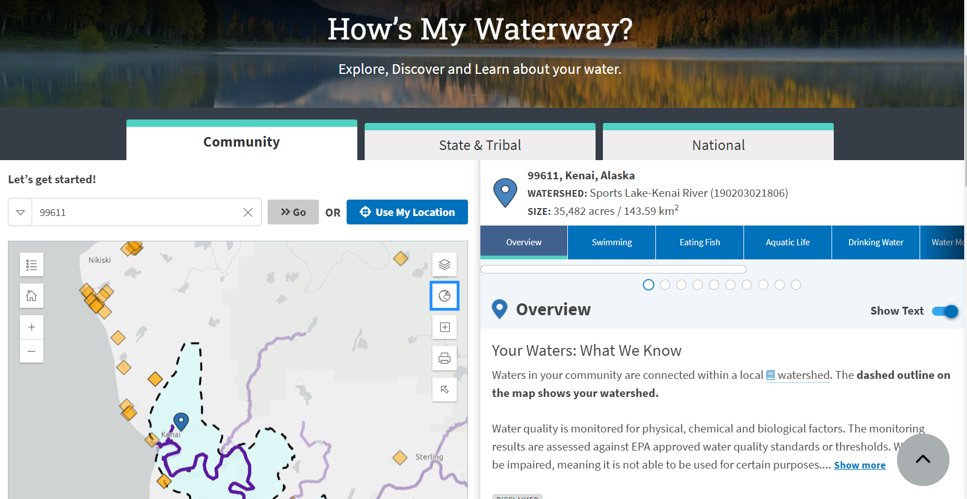
Figure 3 - Screenshot from How’s My Waterway (https://mywaterway.epa.gov/), an online interactive map interface that allows non-technical users to discover, query, and visualize public water quality data.

Stage I - Ensure up-to-date data is accessible in an online interactive map interface

- Task A1 - Data archival: KWF will ensure all up-to-date water quality monitoring data that has not yet been addressed in KWF’s previous CWMP project is archived and accessible through the EPA Water Quality Portal (www.waterqualitydata.us).
  - While archival of project years 2014 - 2021 were part of the previous CWMP project, archiving project years 2022 - 2025 will be part of the proposed CWMP project. KWF is not requesting funding to address any additional or future years during the proposed project period.
  - The data archival process involves two steps:
    - Subjecting annual water quality data to a detailed QA/QC review, using a list of step-by-step quantitative procedures provided by the Alaska Department of Environmental Conservation. An example of these methods for 2021 project data can be accessed by visiting Appendix A of KWF’s in-progress draft report, “Water Quality Assessment of the Kenai River Watershed from 2000 to 2021,” hosted online as an interactive document (Meyer 2024) (Figure 4). Data that does not meet QA/QC standards outlined in the project QAPP is flagged and may be excluded from further analyses and visualizations.
    - Uploading annual datasets to the EPA Central Data Exchange. KWF has developed an upload template using custom guidance from EPA staff as part of the previous CWMP project. Project year uploads from 2022 - 2025 will be facilitated by the existing template and by the recent experience of the project coordinator.

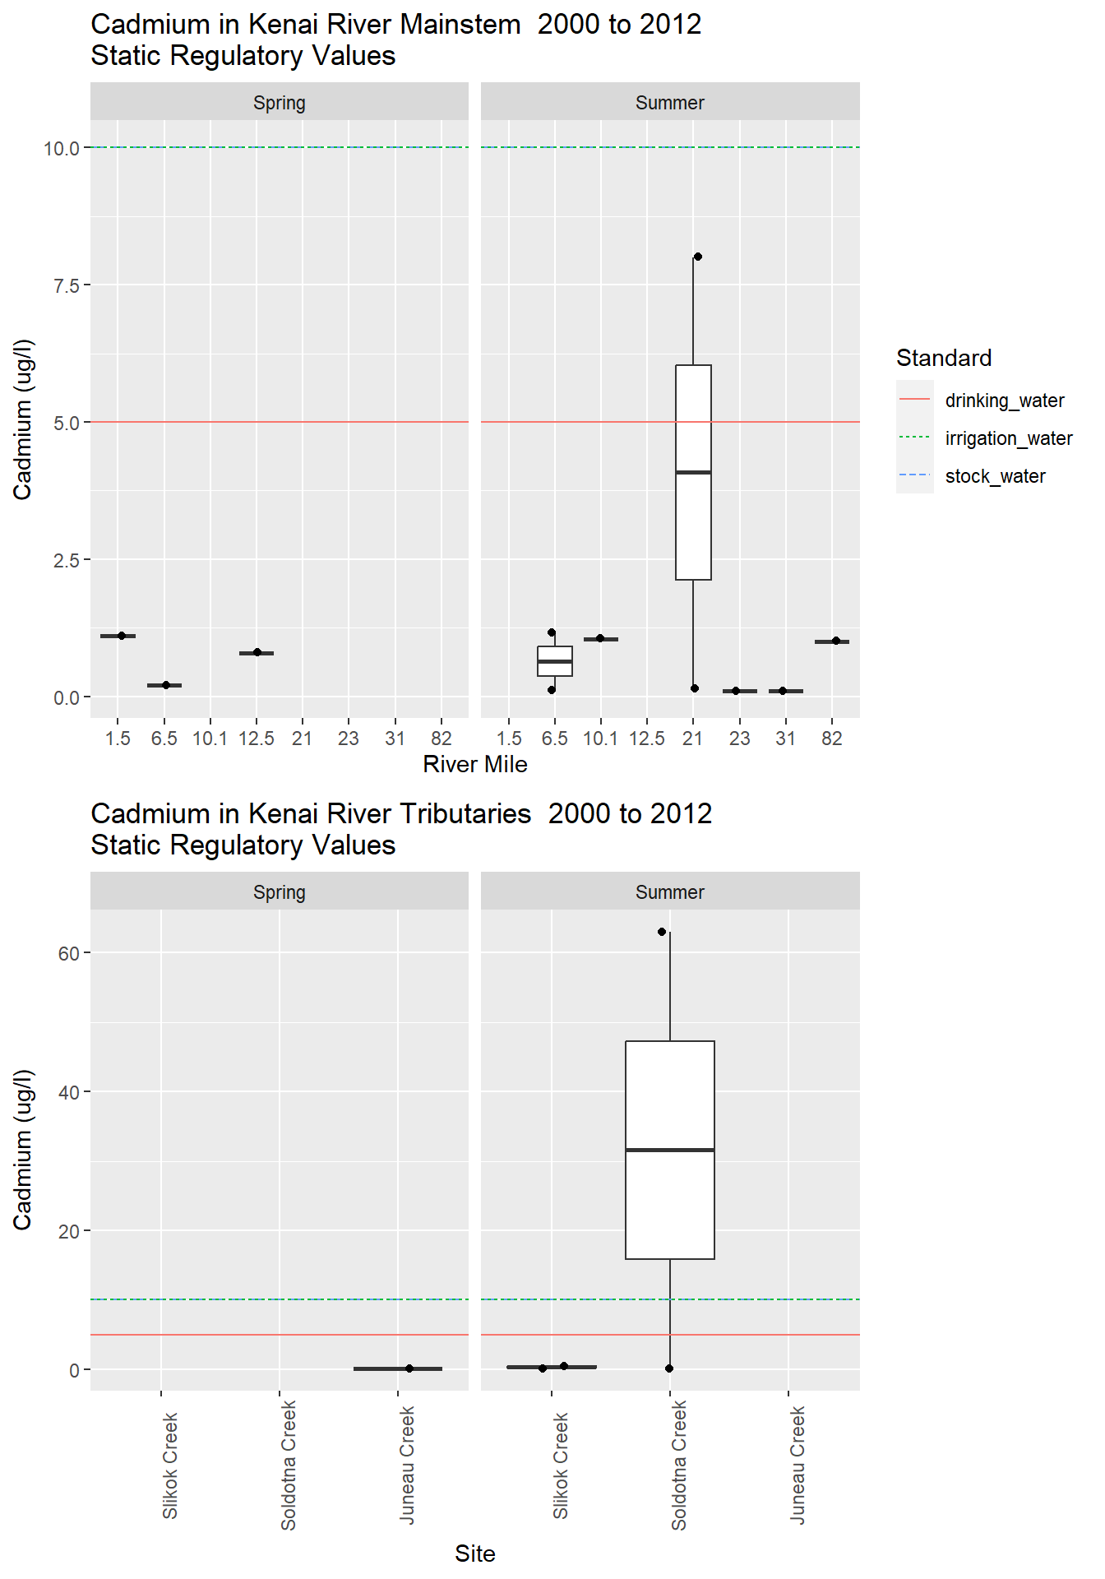
Figure 4 - Example figure from “Water Quality Assessment of the Kenai River Watershed from 2000 to 2021” (Meyer 2024). Parameter values (cadmium as the example here) are summarized as boxplots and assessed within the context of water quality standards provided by ADEC. From https://kenai-watershed-forum.github.io/kenai-river-wqx/

- KWF’s existing draft water quality assessment 2000 - 2021 was developed using CI/CD (continuous integration / continuous update) programming techniques, which will benefit the project proposed here: once new additional results are finalized and uploaded in the EPA water quality portal, all figures in the existing report can be automatically updated to integrate data from 2022 - 2025.
- The report will generate site-specific figures and tables summarizing water quality data in the context of water quality criteria thresholds (ADEC 2020b), portraying trends across space and time.
- The updated report will be titled, “Water Quality Assessment of the Kenai River Watershed from 2000 to 2025,” and will summarize findings from KRBWQM data analysis., following the template of KWF’s previously published comprehensive project report (E. Guerron Orejuela 2016). The report will highlight and summarize results from exploratory data visualization, serving as a starting point for stakeholder engagement in Stage II.

- Task A2 - Preparing data for How’s My Waterway: KWF will carry out custom procedures provided to KWF from the U.S. EPA Water Data Integration Branch to ensure all historical project data is prepared to display in the How’s My Waterway online interface. The steps are a series of code-scripted data management procedures that will align the structure of existing information with the interface’s data input pipelines. For example, some historical water quality data is missing geographical details such as HUC (Hydrological Unit Codes) that are required in order for results to display. Other issues with the historical dataset identified by EPA, such as site name consistency, will be resolved as well.
  - Once project data is displayable in the How’s My Waterway interface, exploratory data analysis is greatly simplified with point-and-click tools to visualize trends of individual parameters at individual sites.

Ongoing assessments of long-term datasets, as recommended in recent ADEC strategy documents (ADEC 2020a) (section 2.4), such as that generated by KWF can help reveal if mitigations already implemented have improved some water quality concerns. Where past interventions have been installed to reduce the impact of urban runoff and other non-point pollution sources––including riparian revegetation, sedimentation basins, diffuser outfalls, rain gardens (City of Soldotna 2016), and beach raking to mitigate fish waste (City of Kenai 2020)––their impact on water quality will be assessed as data allows.

All data management procedures in Stage I will be conducted with reproducibility and transparency as a first-order priority. Analysis code will be written in the R programming language (R Core Team 2024) in RStudio software, and maintained in KWF’s public GitHub repository by the project coordinator (Kenai Watershed Forum 2024b). Where feasible, KWF will leverage existing tools designed to manage data associated with the EPA water quality portal, such as the Tools for Automated Data Analysis package (EPA 2023). KWF will work with a data scientist contractor towards partial fulfillment of these goals, which is reflected in the Contractual section of the proposed budget under “Data Management.”

With all up-to-date project data available to access and display through How’s My Waterway, KWF will be prepared to apply these results in the following stage that focuses on public outreach and feedback on Kenai River water quality trends.

Stage II - Stakeholder Engagement to Guide Planning Effort

- Task B1 - Prepare meeting agendas and logistics
  - KWF will hold a series of five public meetings, with a focus on recruiting attendance from project stakeholders (listed in Task B2) and natural resources management professionals.
  - Different regions of the Kenai River watershed face different water quality management challenges, thus meetings will be customized to the local community where the event is held. Meeting locations will include but are not limited to:
    - Soldotna
    - Kenai
    - Sterling
    - Cooper Landing
    - Moose Pass
  - Meetings will be held in public spaces such as the Cooper Landing Community Center, Soldotna Sports complex, etc. Transportation expenses listed in the budget reflect driving expenses to and from KWF’s office in Soldotna. Miscellaneous project costs in the Materials & Supply section of the budget refer to other expenses associated with these meetings such as facility rental fees.

- Task B2 - Hold meetings
  - The KWF project coordinator, executive director, and environmental science staff will host a series of meetings with assistance from KWF environmental science staff. The meetings will recruit key project partners who are involved with managing water quality in the Kenai River watershed. Prior to these meetings, partners will have received the current technical report described in Stage I, access to data through How’s My Waterway, and other relevant materials in order to have informed discussions based on the latest science. Meetings will have both in-person and virtual attendees, and will be recorded through Zoom or equivalent tool and detailed notes in order to ensure stakeholder input is recorded for consideration.
  - Stakeholders include but are not limited to groups listed in Table 3: ADEC, ADF&G, AKDNR, City of Kenai, City of Soldotna, Cook Inlet Aquaculture Association, KPB, US Fish and Wildlife Service, USFS, Kenaitze Indian Tribe, Salamatof Tribe, Cook Inlet Regional Inc., and others.
  - Input will be solicited from these partners on mitigations for identified water quality threats, gaps in data, and future management practices in their jurisdiction and on a watershed scale. Feedback from stakeholders will be recorded and will influence the Kenai River Water Quality Action Framework (Stage III).
  - Attendees will receive training on how to access data and visualizations of water quality data through the EPA How’s My Waterway online interface.

- Task B3 - Archive & summarize verbal and written feedback
  - KWF environmental science staff will work with the project coordinator to summarize and integrate feedback received from the stakeholder engagement efforts. Audio recordings will be permanently and securely archived in KWF’s Google Drive project filing system, and community-specific information will be assessed for common themes and concerns. A two-page summary document will be prepared for later inclusion in the final Water Quality Action Framework document described in Stage III.

Stage III - Produce Kenai River Water Quality Action Framework
- Task C1 - Produce Kenai River Water Quality Action Framework
  - KWF will produce a Kenai River Water Quality Action Framework document utilizing data analysis from the 2000 - 2025 technical report (Stage I), stakeholder input (Stage II), and past and ongoing water quality management projects as a foundation. This framework will build on existing plans and ongoing projects and will serve as a road map for future water quality management in the Kenai River watershed (see page 17, “KWF will build on multiple previous efforts…”). The document will be written for non-technical audiences, but will draw heavily on results highlighted in the technical report described in Stage I of this proposal.
  - The document will focus on highlighting specific monitoring sites where water quality exceedances have been identified, and pairing these data-backed concerns with potential solutions discussed during stakeholder engagement meetings. For example, a tributary that is experiencing exceedances in parameters associated with impervious surface runoff (dissolved metals, hydrocarbons, etc) may be a priority candidate for green stormwater infrastructure
  - The document will propose community-specific mitigation plans involving strategic solutions such as phytoremediation tactics, riparian restoration efforts, strategic development, wetland preservation, and watershed user and landowner education.
  - Producing the Water Quality Action Framework document will employ the services of a graphic designer to create compelling visuals that summarize results and recommendations. This is reflected in the proposed budget under “Graphic Design.”

Evaluation Criteria

A. Watershed Group Diversity and Geographic Scope
Sub-criterion No. A1. Watershed Group Diversity

By its nature, KWF works with a broad group of partners and has a diverse membership. From federal, state, and local entities, to Tribes, corporations, other nonprofits, and individuals, KWF takes an inclusive, community-based approach and prioritizes collaboration in all of its projects. Table 3 shows the group of partners who will be directly involved with the project as collaborators. These partners will be included in the planning process either directly or through regular meetings of the KPFHP, which KWF coordinates. The stakeholder engagement portion of the proposed work illustrates an approach for engaging with these partners and incorporating their input into the project.

KWF will primarily engage with land managers and other organizations who participate in research and science-driven management to conduct the technical components of this proposal. However, the outreach done through this proposal will engage the entire constituency of KWF. For example, the Adopt-A-Stream program engages K-8 students throughout the Kenai Peninsula who will receive watershed education that will include results from this project. Over 100 Stream Watch volunteers of all ages and backgrounds will also annually receive basic education on this project and the findings of the analyses done––those volunteers will deliver educational messaging based on this CWMP Phase I project to thousands of members of the public at high-use fishing sites on the Kenai River in order to promote river conservation practices among the general public. KWF membership, which includes over 500 donors, will receive regular updates in mailings and emailings about the project. This membership is highly representative of the stakeholders within the watershed.

KWF engages frequently with an array of partners in the fishing community including anglers, personal use, customary & traditional (subsistence), and commercial fishers. Those groups will be included in the stakeholder engagement and outreach components (Stage II) of this project. It is important to note that KWF does not advocate on behalf of any particular fishing group, but rather strives to provide high quality information and programs that benefit the health of regional watersheds and fish habitat. Part of KWF’s success is that the organization refrains from being involved in allocative issues. Rather, KWF fulfills its mission as a forum by ensuring that issues of watershed management are considered with representation from the broadest spectrum of area stakeholders.

A constituency that will be particularly important to the outcomes of this project is private landowners whose property is on or near waters of the Kenai River watershed. KWF, along with the Kenai River Center, which is run by KPB, has a long history of working with landowners on projects such as creating riverside buffers, ensuring the use of light penetrating platforms for fishing and river access to ensure bank stability and natural filtration of runoff through vegetated riverbanks.

Sub-criterion No. A2. Geographic Scope
While KWF works across the KPB, this CWMP Phase I project is focused on the Kenai River
watershed, which makes up a large portion of USGS HUC 19020302 (see Figures 5.1 and 5.2).

As a watershed organization, KWF strives to work with all stakeholders in the Kenai River watershed. This engagement is achieved through KWF’s education, research, and restoration programs as well as through KWF’s role coordinating the KPFHP. KWF’s membership and long-term partnerships represent the entire scope of the watershed, and the entirety of HUC 19020302. While there are other watersheds within HUC 19020302, many of them are on undeveloped public lands or lands far less developed than those within the Kenai River watershed, which is considered the gem of the Kenai Peninsula.

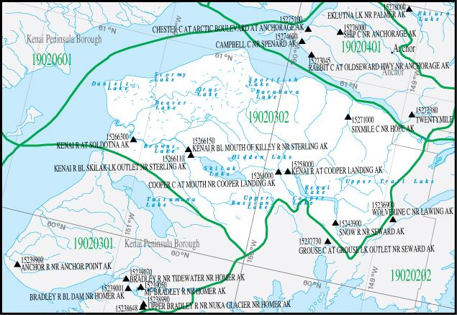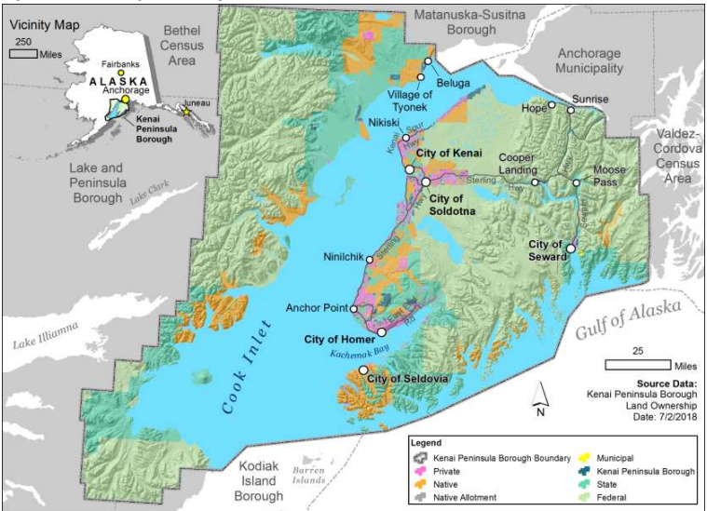
Figures 5.1 and 5.2: Left: USGS HUC 19020302 including the Kenai River watershed. Right: KPB land ownership map, adapted from KPB Comprehensive Plan (KPB 2019)

B. Addressing Critical Watershed Needs
Sub-criterion No. B1. Critical Watershed Needs or Issues
The Kenai River watershed faces an intense set of challenges to maintain its ecological resilience and water quality, many of which can be influenced by local actions (Figure 6). The recently-updated KPFHP Freshwater Conservation Action Plan (KPFHP 2022) identifies and ranks the threats facing various freshwater systems on the Kenai Peninsula including those types that make up the Kenai River watershed: glacially fed systems with lakes such as the Kenai River mainstem are ranked with an overall threat level of medium and lowland groundwater/wetland dominated systems such as the Moose River have an overall threat level of high. The primary challenges identified by KPFHP are development in the riparian zone, a warming climate, and aquatic invasive species. Another threat not mentioned, but one that does threaten water quality, is intensive recreational use.

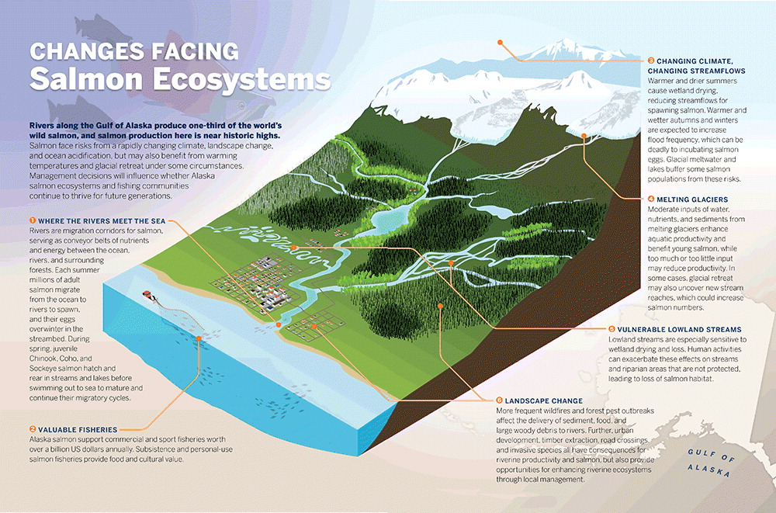
Figure 6. Summary of changes facing salmon ecosystems in Southcentral Alaska, such as the Kenai River watershed. Figure from Schoen et al. 2017, adapted with author’s permission.

The salmon runs of the Kenai River watershed are a primary economic driver for the Kenai Peninsula region, and these fish rely on clean, cold water with suitable spawning habitat. While many Alaska wild salmon population sizes remain robust, Gulf of Alaska Chinook (king) salmon are currently petitioned for Threatened status (NOAA 2024). With respect to freshwater habitat, development is driving multiple challenges with water quality from stormwater runoff, increased impervious surface area, reduced vegetative buffers around water bodies, and increasing levels of water pollutants. KWF is particularly concerned with elevated levels of zinc and copper found in water samples (Sires 2017b) as well as fecal coliform and enterococci found in beach sampling at the mouth of the Kenai River (B. Meyer 2021), the site of a large personal-use fishery. Climate change is also warming waters in the watershed and increasing glacial and snow melt, initiating a cascade of long-term habitat changes that affect salmon habitat in complex ways (Mauger et al. 2017; O’Neel et al. 2015; B. E. Meyer et al. 2023). While the Kenai River mainstem is glacially fed and relatively temperature stable, non-glacial lowland tributaries are warming at accelerated rates. Heavy recreational use has led to numerous challenges including hydrocarbons in the river (a problem much improved by an effort that KWF spearheaded to transition away from two-stroke boat motors), riverbank degradation from vegetation trampling, and wake-driven turbidity increases.

Sub-criterion No. B2. Developing Strategies to Address Critical Watershed Needs or Issues
Through this CWMP Phase I project, KWF will highlight information through data visualization of existing KRBWQM project data from 2000-2025 in order to assess trends in water quality in the watershed and through stakeholder meetings. After conducting primary analysis and identifying new water quality threats or confirming existing threats, KWF will work with an array of stakeholders to identify threats not already identified in the data, potential mitigations, and specific projects to benefit the watershed. This information will be synthesized and priorities will be established in the creation of KWF’s primary goal for this proposed project––a long-term, collaborative, and science driven action framework for managing water quality in the Kenai River watershed. KWF’s secondary goal is that this plan will drive specific actions and projects in the near-term that benefit the watershed.

Should conflicts arise in the production of the plan, KWF will take that opportunity to facilitate discussions among stakeholders who may disagree in order to come to viable solutions to water quality challenges. KWF is an experienced facilitator of projects that benefit the health of watersheds even when disparate groups of stakeholders are in disagreement. The best example of this is KWF’s successful project to solve excessive hydrocarbon levels on the Kenai River that were identified through KWF’s KRBWQM program. The Kenai River was listed as impaired under the Clean Water Act in 2006 due to heightened hydrocarbon levels. A coalition of partners helped enact policy requiring four-stroke motors on the river rather than more polluting two-stroke motors. A rapid transition to four-stroke motors was made possible through the implementation of a buy-back program for two-stroke motors funded through an EPA grant to the Kenaitze Indian Tribe. This program helped to ensure that the hardest hit constituency, fishing guides, would participate in the resolution of the problem. Following this effort, water quality data gathered through KRBWQM has shown the problem to be mitigated and the Kenai River was delisted as an impaired waterway.

With this CWMP Phase I project, KWF will build on multiple previous efforts:
- Kenai River Comprehensive Management Plan (KRCMP): The 1997 KRCMP (AKDNR 1997) which established a broad array of projects for managing the watershed. After the KRCMP was published, KWF was formed to take on the identified action of creating a baseline water quality dataset to guide management of the river, the KRBWQM project. This CWMP Phase I project is intended to take the long term data collected through KRBWQM and to produce an action framework that will guide further planning for managing the watershed. This project is not seeking funding for sampling, but for analysis, stakeholder engagement, and planning efforts.
- Another previous and ongoing effort that this project will build on is the KPFHP Strategic Plan, which guides KPFHP efforts to conserve fish habitat on the Kenai Peninsula (KPFHP 2022). The plan identifies that the primary threats to water quality result from development and climate change, and it provides regional objectives for protecting and restoring water quality and quantity. The results of this CWMP Phase I project would help the KPFHP update the strategic plan and would also guide the management actions of various members of the partnership.
- The Mountains to Sea Strategic Plan (Morton et al. 2015) identifies the need for land managers, private landowners, and other stakeholder organizations to work together broadly on watershed management on the Kenai Peninsula. This CWMP Phase I project will engage Mountains to Sea stakeholders and will help guide collaborative efforts between land managers and landowners to manage the Kenai River watershed.
- The Kenai River Water Quality Action Framework project. Activities in this effort serve as the foundation for those outlined in this current proposal, having accomplished critical tasks related to the Kenai River Baseline Water Quality Monitoring project such as updating the QAPP, curating and archiving historical data, and drafting a technical report due for completion in December 2025 (KWF 2024).
- The Alaska Department of Environmental Conservation’s 2021 - 2022 Kenai River water quality monitoring efforts focused on examining dissolved metals and other parameters in the main stem Kenai River (ADEC 2023). Results from this effort will serve to inform Goal 2 and Goal 3 outlined in this proposal, providing an additional source of data on Kenai River water quality to share with stakeholders and inform the Water Quality Action Plan document.
- Lower Kenai River Impervious Surfaces mapping. KWF recently worked with St. Mary’s University of Minnesota Geospatial Services to develop a detailed map of impervious surfaces in the lower Kenai River, comparing coverage in 1984 vs 2021. The map will serve activities described in Stage II and Stage III of this project by identifying areas where stormwater runoff concentrates pollutants towards hotspot locations, such as sloped edges of large parking lots. Locations where future interventions such as green stormwater infrastructure are suggested as part of these efforts, and will be highlighted as location-specific solutions to water quality concerns.

C. Implementation and Results
Sub-criterion No. C1—Project Implementation

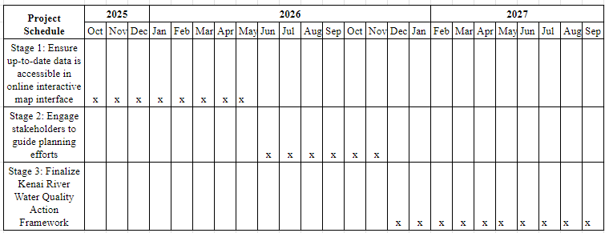
Table 4: Proposed schedule of project activities by stage.

Below is a breakdown of project stage milestones and the direct cost associated with each stage:

- Ensure up-to-date data is accessible in online interactive map interface
  - Milestone: Ensure public availability of water quality data from year 2000 - present in the EPA Water Quality Portal, and is accessible through the EPA How’s My Waterway online interactive map application.
  - Start date: October 1, 2025
  - End date: May 31, 2026
  - Cost: $ 42,433
- Engage stakeholders to guide planning efforts
  - Milestone: Collect and assess feedback on up-to-date technical report from local stakeholders to guide planning priorities.
  - Start date: June 1, 2026
  - End date: November 30, 2026
  - Cost: $ 31,825
- Finalize Kenai River Water Quality Action Framework
  - Milestone: Using results from the technical report and stakeholder input, produce an action framework document detailing specific strategies and locations prioritizing water quality management actions.
  - Start date: December 1, 2026
  - End date: September 30, 2027
  - Cost: $ 53,041

Sub-criterion No. C2—Building on Relevant Federal, State, or Regional Planning Efforts
This project will produce a robust strategy for beginning to address the challenge of nonpoint
source water pollution in the Kenai River watershed, from both a prevention and restoration
standpoint. Project goals align with those outlined several regional and statewide planning
Documents.

- AKDNR’s Kenai River Comprehensive Management Plan served as the original impetus for biannual water quality monitoring (AKDNR 1997).
- ADEC’s, “Alaska Nonpoint Source Water Pollution Prevention and Restoration Strategy'' document highlights the Kenai River as high priority for watershed “planning, protection and restoration” and as a priority among water bodies at risk to “protect and maintain” (ADEC 2020a)
- City of Soldotna’s “Envision Soldotna 2030 Comprehensive Plan'' highlights KWF specifically as a group to work with, “... to promote interactive learning opportunities focused on the river for local schools, residents and visitors'' (City of Soldotna 2011).
- KBP’s 2019 Comprehensive Plan includes objectives related to maintaining quality fish habitat to benefit the local community, economy and environment, including to, “Protect and enhance the natural systems that support healthy sustainable sportfish habitats and populations” and to “Support continued sportfish research, monitoring and education efforts” (KPB 2019).
- The KPFHP Strategic Plan and Freshwater Conservation Action Plan document identifies threats to freshwater systems on the Kenai Peninsula and strategies for mitigating these threats including development in the watershed and climate change (KPFHP 2022).

D. Department of the Interior and Bureau of Reclamation Priorities
This project aligns with several U.S. Dept. of the Interior (DOI) and Reclamation priorities:

Table 5: Visual representation of project alignment with DOI and Reclamation priorities
Priorities | Project Support
Department of the Interior
1a. Utilize science to identify best practices to manage land and water resources and adapt to changes in the environment | This project will utilize analysis of a robust dataset to inform Kenai River watershed management and adaptation to climate change, pollution, and other threats.
1e. Foster relationships with conservation organizations advocating for balanced stewardship and use of public lands | Various conservation organizations will participate in this project in collaboration with DOI agencies including Fish and Wildlife Service and the National Park Service.
3a. Be a better neighbor with those closest to our resources by improving dialogue and relationships with persons and entities bordering our lands; | This project will support collaboration between DOI and other federal entities and private landowners as well as local governments to effectively manage the Kenai River watershed together.
3b. Expand the lines of communication with Governors, state natural resource offices, Fish and Wildlife offices, water authorities, county commissioners, Tribes, and local communities | Entities from city, borough, and state government will participate in this project, building on established relationships to achieve constructive and collaborative management.
Bureau of Reclamation
1. Increase Water Supplies, Storage, and Reliability under WIIN and other Authorities to Benefit Farms, Families, Businesses, and Fish and Wildlife | This project will increase water reliability by helping ensure state and federal standards for parameters of concern are within acceptable boundaries. It is part of a larger effort to ensure sufficient water quantity and quality for fish and wildlife on the Kenai Peninsula.
6. Improve Water Supplies for Tribal and Rural Communities | As drinking water supply is generally not threatened in Tribal and rural communities in the Kenai River watershed, this project does not target improving water supply, but the project will support and enhance water quality for salmon, which is a staple of the local food supply, economy, and culture.

Project Budget
Budget Proposal
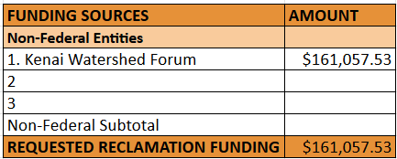

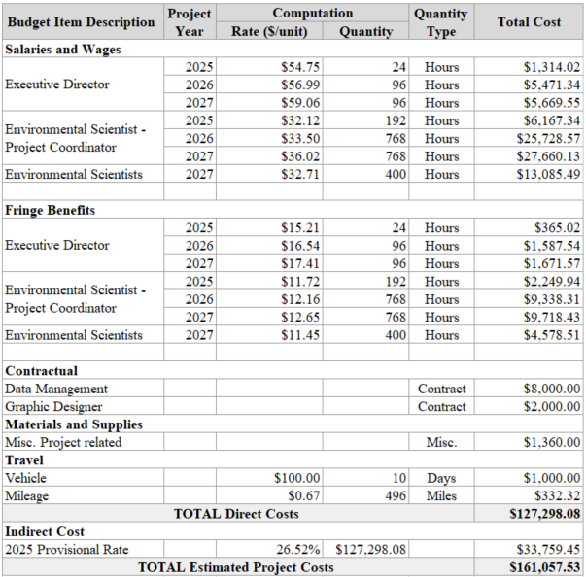

Budget Narrative
KWF requests $161,057.53 in funds to complete this WaterSMART CWMP Phase 1 project.

Salaries and Wages: $85,096.44
- Trenten Dodson, Executive Director, $54.75/hr (Year 1), $56.99 (Year 2), $59.06 (Year 3) @ 200 hrs = $12,454.90
  - As Project Officer, Trenten will oversee all aspects of project completion and will participate directly in Stages I-III, playing a key role in the finalization of the technical report, stakeholder meetings, and the finalization of the Kenai River Water Quality Action Framework.
- Benjamin Meyer, Environmental Scientist, $32.12/hr (Year 1), $33.50 (Year 2), $36.02 (Year 3) @ 1728 hrs = $59,556.05
  - Benjamin will play a primary role in Stages I-II of the proposed project as well as a critical role in Stage III.
- KWF Staff, $32.71/hr x 400 hrs = $13,085.49
  - Contributions from several additional KWF staff will be essential in Stage III of the project, assisting with stakeholder engagement, communications, and writing the finalized Action Framework document. The Stream Watch coordinator will contribute specialized knowledge in stakeholder engagement, the Restoration coordinator will contribute technical knowledge in proposed water quality interventions and solutions.

All salary rates are based on the average for the person occupying the position

Fringe Benefits: $29,509.32
- Includes paid time off, sick leave, healthcare stipend, IRA match, and payroll taxes.

Contractual: $10,000
- For activities in stage I, “Ensure up-to-date data is accessible in online interactive map interface”: data scientists with River Focus Water Resource Consultants will work with KWF project manager Benjamin Meyer to finalize a robust reproducible data pipeline to efficiently move water quality data from raw form to accessible through the EPA How’s My Waterway tool. 100 hours x $80/hour: $8,000. Final rates TBD.
- A graphic designer will be contracted to assist with final document design for the Kenai River Water Quality Action Framework and for documents or graphics used in stakeholder engagement. Final cost TBD.

Materials and Supplies: $1,360.00
- Printing of project documents - $1000, this includes printing of maps, graphics, reports and other required documents. Cost assessed based on past experience.
- Miscellaneous supplies including office supplies - $360

Travel: $1,332.30
- Includes use of KWF vehicles charged at $100 per day for 10 days plus the IRS mileage rate estimated at $0.67/mile for 496 miles during the project period. This day travel is for staff to attend meetings with stakeholders.

Indirect Cost: $33,759.45
- KWF has a provisional indirect rate for the year 2025 of 29.79%. This rate is applied to the direct costs of the project, $33,759.45.

Equipment: $0

Third-Party In-Kind Contributions: $0

Environmental and Regulatory Compliance Costs: $0
- This project requires no permitting or environmental review.

Appendix
KWF Staff Profiles
Trenten Dodson, Executive Director
Trenten has a background in fisheries management and aquatic habitat restoration and brings a wealth of knowledge and experience to the organization. He has been an engaged community member and professional in the field since 2001, making significant contributions to various organizations in Alaska like Cook Inlet Aquaculture Association, Cook Inlet Regional Citizens Advisory Council, and the Kodiak Regional Aquaculture Association.

Benjamin Meyer, Water Quality Coordinator
Benjamin earned B.S. degrees in Biology and Biochemistry, and an M.S. in Fisheries, from University of Alaska Fairbanks. He is currently the project manager for KWF’s Kenai River Baseline Water Quality Monitoring project. His research focuses on understanding the effects of climate change and development on juvenile salmon habitat. He has authored one peer-reviewed scientific journal article and co-authored five. Benjamin came to KWF in 2020 after working as a project manager at the Freshwater Ecology lab at University of Alaska Fairbanks.

Candace Nakagawa, Accounts and Grants Manager
Candace has over twenty years of experience in the operations of nonprofits, working internationally and in the U.S. Candace joined Kenai Watershed Forum in 2022 and has managed grants and contracts for KWF at all levels: federal, state, borough, and city as well as corporate and foundations. Candace is solely responsible for all A/P, A/R, payroll, and financial reporting.

Katey Shedden, Education Specialist
Katey is originally from Fort Worth, TX and majored in Environmental Studies and Mass Media Communications at college at Chaminade University of Honolulu. Since 2017, she has worked in environmental education work on the Kenai Peninsula. Katey has also worked for the U.S. Fish and Wildlife Service and non-profits in Wisconsin, Louisiana, and Hawaii connecting people of all ages to the natural spaces around them.

Bonnie Bernard, Restoration Coordinator
Bonnie joined the Kenai Watershed Forum with over 10 years of experience in field botany & ecology, and 9 years of Alaskan residency. Their work at the KWF includes survey and monitoring efforts, geospatial analyses, and various fieldwork in support of native vegetation research and invasive species management.

Brandon Drzazgowski, Stream Watch Coordinator
Brandon received a double major in Environmental Studies and Sustainability & Sustainable Parks Recreation and Tourism at Michigan State University. He manages KWF’s Stream Watch program, working and interacting with various volunteers on projects including trash clean up, education/outreach, and stream bank remediation and protection.

Sara Aamodt, Environmental Scientist and Development Coordinator
Sara attended Louisiana Tech University, where she majored in Environmental Science. As development Coordinator she manages the KWF membership base, and shows our supporters how much KWF appreciates community members and their support.

References
ADEC. 2020a. “Alaska Nonpoint Source Water Pollution Prevention and Restoration Strategy.” Alaska Department of Environmental Conservation. https://dec.alaska.gov/water/nonpoint-source-control/.
———. 2020b. “Water Quality Standards.” 18 AAC 70. Alaska Department of Environmental Conservation. https://dec.alaska.gov/water/water-quality/standards/.
———. 2023. “2022 Water Quality Final Report Kenai River, Alaska.” Alaska Department of Environmental Conservation. https://dec.alaska.gov/media/m5faa5fu/kenai-river-wq-monitoring-final-report-6-20-2023.pdf.
AKDNR. 1997. “Kenai River Comprehensive Management Plan.” http://dnr.alaska.gov/parks/plans/krsmapln/krsma_1997_complete.pdf.
City of Kenai. 2020. “City Manager Dipnet Report.”
City of Soldotna. 2011. “Envision Soldotna 2030 Comprehensive Plan.” https://www.soldotna.org/home/showpublisheddocument?id=286.
———. 2016. “2015 Drainage Master Plan.”
Dorava, Joseph M., and Alexander M. Milner. 2000. “Role of Lake Regulation on Glacier-Fed Rivers in Enhancing Salmon Productivity: The Cook Inlet Watershed, South-Central Alaska, USA.” Hydrological Processes 14 (16-17): 3149–59.
EPA. 2011. “Nonpoint Source Program Success Story, Alaska: Upgrading Boat Motors Reduces Hydrocarbon Pollution.” EPA 841-F-11-001B. Environmental Protection Agency. https://19january2017snapshot.epa.gov/sites/production/files/2015-10/documents/ak_kenai.pdf.
———. 2023. “Water Quality Portal – Tools for Automated Data Analysis (TADA).” May 1, 2023. https://www.epa.gov/waterdata/TADA.
Guerron Orejuela, Edgar. 2016. “Water Quality Assessment of the Kenai River Watershed from July 2000 to July 2014.” Kenai Watershed Forum. https://dec.alaska.gov/media/16756/kenai-river-baseline-monitoring-report-final-zncuappendix.pdf.
Guerron Orejuela, E. J. 2017. “Water Quality in Alaska’s Kenai River, United States of America; Past, Present and Future.” Edited by R. Kounadi. M.S., University of Salzburg.
Kenai Watershed Forum. 2024a. “Impervious Surface Change in the Lower Kenai River 1984 - 2022 (Unpublished).” Soldotna, AK.
———. 2024b. “KWF GitHub Homepage.” 2024. https://github.com/Kenai-Watershed-Forum.
KPB. 2013. “Ordinance 21.18. - Anadromous Waters Habitat Protection.” https://library.municode.com/ak/kenai_peninsula_borough/codes/code_of_ordinances?nodeId=TIT21ZO_CH21.18ANWAHAPR.
———. 2019. “Kenai Peninsula Borough Comprehensive Plan.” Kenai Peninsula Borough. http://kpbcompplan.com/wp-content/uploads/2020/01/KPBCompPlan2019_FullPlan-1.pdf.
“KPEDD.” 2020. Kenai Peninsula Economic Development District. 2020. https://kpedd.org/kenai-peninsula-borough/.
KPFHP. 2022. “Kenai Peninsula Fish Habitat Partnership Freshwater Conservation Plan.” https://www.kenaifishpartnership.org/wp-content/uploads/2022/08/Kenai-Peninsula-Fish-Habitat-Partnership-Freshwater-Conservation-Plan-August-2022.pdf.
KWF. 2016. “The Way Forward: Action Plan for 2016-2020.” Kenai Watershed Forum. https://kenaiwatershed.org/wp-content/uploads/2015/03/KWF.PLAN_.2016.web_.pdf.
———. 2023. “Quality Assurance Project Plan Revisions Completed.” Kenai Watershed Forum (blog). 2023. https://www.kenaiwatershed.org/news-media/qapp-revisions-completed-2023/.
———. 2024. “Kenai River Baseline Water Quality Monitoring.” 2024. https://www.kenaiwatershed.org/kenai-river-baseline-water-quality-monitoring/.
Leaf, Andrew, Megan Haserodt, Steve Westenbroek, Benjamin Meyer, and Joshua Koch. 2023. “Forecasting Future Stream Temperatures in the Beaver Creek Basin in Southcentral Alaska.” Presented at the American Geophysical Union, San Francisco.
Mauger, Sue, Rebecca Shaftel, Jason C. Leppi, and Daniel J. Rinella. 2017. “Summer Temperature Regimes in Southcentral Alaska Streams: Watershed Drivers of Variation and Potential Implications for Pacific Salmon.” Canadian Journal of Fisheries and Aquatic Sciences. Journal Canadien Des Sciences Halieutiques et Aquatiques 74 (5): 702–15.
Meyer, B. 2021. “2020 Kenai Beach Bacteria Monitoring Report.” Kenai Watershed Forum. https://dec.alaska.gov/media/23091/kenai-river-beach-2020-final-report.pdf.
Meyer, Benjamin E., Mark S. Wipfli, Erik R. Schoen, Daniel J. Rinella, and Jeffrey A. Falke. 2023. “Landscape Characteristics Influence Projected Growth Rates of Stream‐resident Juvenile Salmon in the Face of Climate Change in the Kenai River Watershed, South‐central Alaska.” Transactions of the American Fisheries Society, March. https://doi.org/10.1002/tafs.10397.
Morton, J. M., D. R. Magness, M. McCarty, D. Wigglesworth, R. Ruffner, M. Bernard, N. Walker, et al. 2015. “Kenai Mountains to Sea: A Land Conservation Strategy to Sustain Our Way of Life on the Kenai Peninsula.” Kachemak Heritage Land Trust. https://kenaiwatershed.org/wp-content/uploads/2019/03/Kenai-Mountains-to-Sea-Strategic-Plan_5nov2016_compressed.pdf.
NOAA. 2024. “Petition to List Gulf of Alaska Chinook Salmon as Threatened or Endangered under the Endangered Species Act - Comment Period Extended to September 6, 2024.” NOAA. July 29, 2024. https://www.fisheries.noaa.gov/action/petition-list-gulf-alaska-chinook-salmon-threatened-or-endangered-under-endangered-species.
O’Neel, Shad, Eran Hood, Allison L. Bidlack, Sean W. Fleming, Mayumi L. Arimitsu, Anthony Arendt, Evan Burgess, et al. 2015. “Icefield-to-Ocean Linkages across the Northern Pacific Coastal Temperate Rainforest Ecosystem.” Bioscience 65 (5): 499–512.
R Core Team. 2024. R: A Language and Environment for Statistical Computing (version 4.4.1). https://www.R-project.org/.
Schoen, Erik R., Mark S. Wipfli, E. Jamie Trammell, Daniel J. Rinella, Angelica L. Floyd, Jess Grunblatt, Molly D. McCarthy, et al. 2017. “Future of Pacific Salmon in the Face of Environmental Change: Lessons from One of the World’s Remaining Productive Salmon Regions.” Fisheries 42 (10): 538–53.
Sires, Jeff. 2017a. “A Review of Potential Zinc and Copper Pollution Sources in the Kenai River Watershed.” Kenai Watershed Forum . https://dec.alaska.gov/media/5181/zcliteraturereviewfinal.pdf.
———. 2017b. “Kenai River Watershed Zinc and Copper Pollution: A Summary of Data Analysis, Literature Review Results, and Suggested Actions.” Kenai Watershed Forum. https://dec.alaska.gov/media/16761/kenai-river-zinc-and-copper-pollution-study.pdf.
U.S. Census Bureau. 2020. “Kenai Peninsula Borough, Alaska - Census Bureau Profile.” 2020. https://data.census.gov/profile/Kenai_Peninsula_Borough,_Alaska?g=050XX00US02122.
[End of Technical Proposal]

Environmental and Cultural Resources Compliance
The proposed project does not involve construction or landscape modification activities, thus the concerns in this section do not apply. Regarding species listed or proposed to be listed as a Federal threatened species, Gulf of Alaska Chinook salmon, which includes Kenai River Chinook salmon, are currently petitioned for listing. The proposed project will provide valuable background information regarding this topic.

Required Permits and Approvals
The proposed project does not require permits or approvals in advance. The project does not involve construction activities, collecting new data, or handling animals.

Overlap or Duplication of Effort Statement
Some deliverables included in the new proposal were previously included in agreement R22AP00057 for the project titled, “Kenai River Water Quality Action Framework.” However, in spring 2025 KWF was granted a scope of work modification due to staff changes and logistics limitations. At the recommendation of BOR staff, KWF is including many deliverables that were removed from the previous scope of work as part of this new proposal. Specifically, the activities removed from the previous project that are part of this new proposal are:

- Ensure that all current project water quality data is accessible in an online interactive map interface for both laymen and professionals (Goal 1 of new proposal)
  - At the time of the previous project’s proposal writing, the EPA’s How’s My Waterway online interactive map platform was still new and not widely publicized. A deliverable in the past proposal included developing a similar stand-alone tool for the KWF project; however today it is clear that tying project data into the existing capabilities of How’s My Waterway will be a superior choice for its robust capabilities and existing connections to EPA data management systems.

- Engage stakeholders to guide planning efforts (Goal 2 of new proposal)
  - Deliverables in the current modified agreement R22AP00057 include stakeholder outreach efforts focused on a) renewing the project Memorandum of Understanding, and b) recruiting technical partners for future project work. Neither of these activities overlap with deliverables outlined in the new proposal, which instead proposes to hold a series of stakeholder engagement meetings disseminating results and integrating feedback. This high-priority goal was excised from the original scope of work due to timing and resource limitations.

- Produce a Kenai River Water Quality Action Framework to serve as a foundation for water quality management in the Kenai River watershed (Goal 3 of new proposal)
  - The new proposal includes developing a separate, standalone document from the technical report, targeted for a more general audience of managers and property owners. The high-priority goal was excised from the original scope of work due to timing and resource limitations as well as staff changes.

Conflict of Interest Disclosure Statement
Kenai Watershed Forum declares no conflicts of interest related to the proposed project activities.

Uniform Audit Reporting Statement
Kenai Watershed Forum expended less than $750,000 in Federal award funds in the current fiscal year, thus this requirement does not apply.

SF-LLL: Disclosure of Lobbying Activities
Kenai Watershed Forum has no lobbying activities to disclose, thus form SF-LLL is not included. A Certification Regarding Lobbying form is included because the funding request is for greater than $100,000.

https://kenai-watershed-forum.github.io/kenai-river-wqx/

